# CS 340 README

## Project/Project Title

## CS-340 Grazioso Salvare Rescue /the Austin Animal Center (AAC) Database Web Portal

The purpose of this application is to provide the database user(s) and stakeholders a convenient, user-friendly web-based interface to query for prescribed data from the Austin Animal Center (AAC) database. Program access is limited to the “animals” collection of the database, which tracks and manages animals in the Austin, Texas metropolitan and suburban areas. The program’s primary objective is to facilitate queries for dogs of various combinations of breeds, mixes, genders, and age ranges that qualify them as suitable candidates for the challenges of the Grazioso Salvare rescue training program. Based on historical data, this set of dog breeds combined with their prescribed sex and age attributes minimize the risk of failure while maximizing the likelihood of their proficiency in real world rescue and tracking scenarios.

**Tools - Major Components**

This application is comprised of three primary components: A MongoDB database, application programming interfaces (APIs), and a web-based dashboard. The components are described in more detail below:

1. MongoDB. MongoDB is a “Not Structured Query Language “(NoSQL), flexible, cross-platform database engine. As it is a NoSQL database, it is not bound by rigid, predefined relationships and structures. Instead, it is built upon a simpler, more flexible structure based on documents. MongoDB tends to be more user-friendly and easily deployed than its SQL counterparts.
2. MongoDB API and PyMongo. MongoDB has a versatile built-in API. Database access and CRUD operations are facilitated using the PyMongo Python driver.
3. Dashboard Components. The program utilizes web-based dashboard APIs for interacting with the database dashboard's frontend. The Dash components present the data via web pages in clean, intuitive ways, including a data table, pull-down menu, and radio buttons. Visualizations are also provided using Dash core components, including an interactive pie chart and geolocation map that responds to pull-down menu selections.

## Motivation

Necessity is the mother of invention, and the Grazioso Salvare use case is no exception. The need for highly trained, competent tracking and rescue dogs has steadily increased over the last decade. All indications are that this trend will continue well into the future. As such, it was imperative that the Grazioso Salvare organization expand and streamline the process of finding qualified dog candidates for its training programs to keep pace with the growing need. The Grazioso Salvare organization has teamed with the Austin Animal Center (AAC) in order to meet this goal. This program is built upon lessons learned over time and careful historical data analysis. It facilitates searches for dogs by breed groups, sex, and age ranges that are most likely to succeed in their rigorous and costly training programs, and more importantly, real-world scenarios in their specialized rescue and tracking roles. Additionally, the program is accessible from any computer anywhere with Internet access and a web browser. Its database query capabilities instantly return rescue dog candidate information in the Austin, TX area.

## Getting Started

Required Items:

1. MongoDB Database engine installed and operating on a local or remote network accessible server.
2. Data source. Import the xxxxxx-shelter_outcomes.csv
3. MyClassFile.py Python file containing the “DatabaseLayer” Create, Read, Update, Delete (CRUD) class.
4. Jupyter Notebook ipynb file titled “ProjectTwoDashboard”.
5. The Grazioso Salvare business logo image file titled “Grazioso_Salvare_Logo.png”.
6. Host computer with a network connection and web browser.

## Installation

The MongoDB Database engine has been installed and is running on a local or remote server. At a command prompt, import the file name aac_shelter_outcomes.csv to create the AAC database and the animal’s collection.

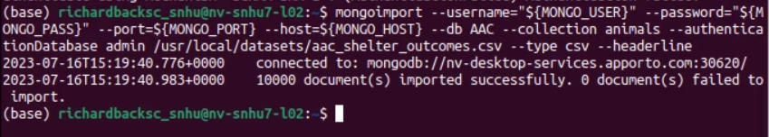

## Create a MongoDB username and password that is the same as those used in the class file and in the Jupyter Notebook (ipynb) files.

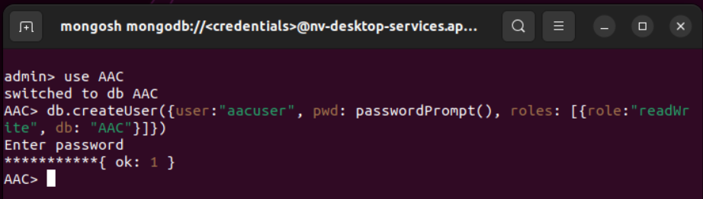

## Place a copy of “MyClassFile.py” on the server desktop or in a directory location that corresponds to the path statement in the “DatabaseLayer” class and the “ProjectTwoDashboard.ipynb” files.

## Launch the “Austin Animal Center (AAC) Database Web Portal” by opening the “ProjectTwoDashboard.ipynb” file in Jupyter Notebook and clicking the “Run Button” at the top of the screen.

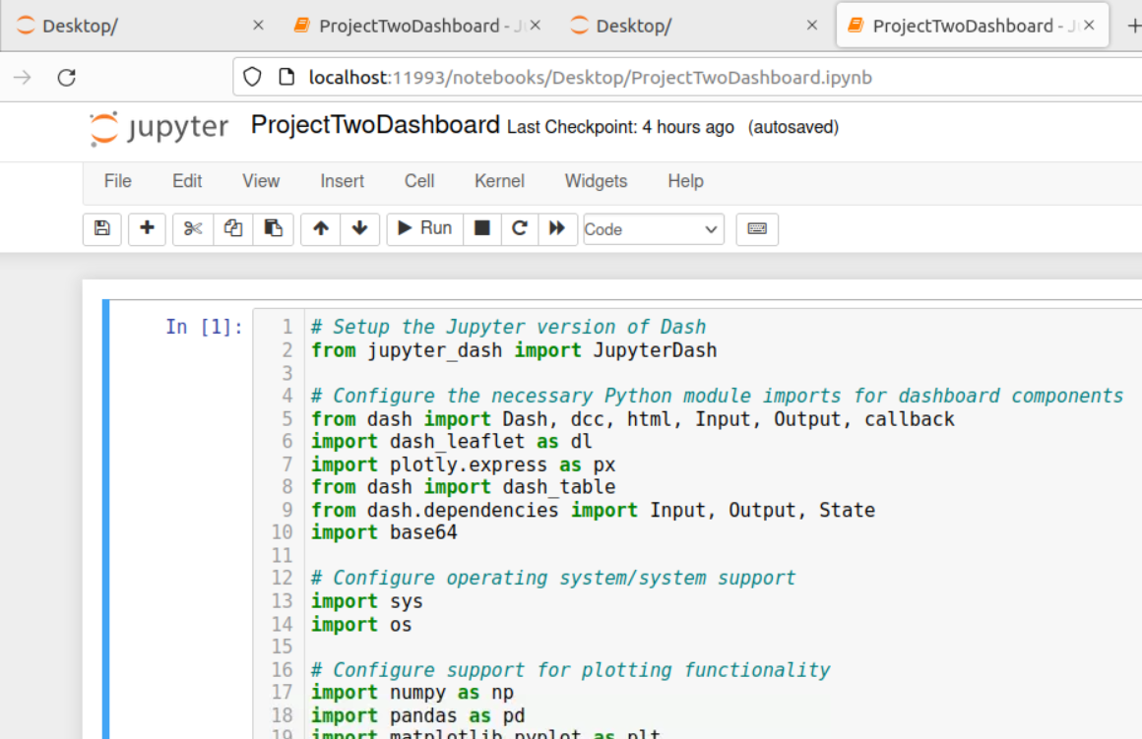

When you run the “ProjectTwoDashboard.ipynb” file, it will do two things: 1. Verify successful authentication by returning the URI used in the “DatabaseLayer” CRUD class, and 2. Return counts of candidate dogs from the queries within the file. These counts will be displayed at the bottom of the Jupyter Notebook cell. These are all active debug functions used along the way to verify step-by-step functionality.

When file execution is complete, Jupyter Dash returns a URL at the bottom of the cell, which when clicked, renders the Dashboard (see below).

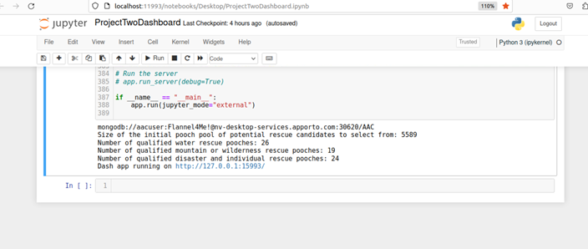

After clicking the URL, the “Austin Animal Center (AAC) Database Web Portal” landing page will be displayed in a web browser (see below).

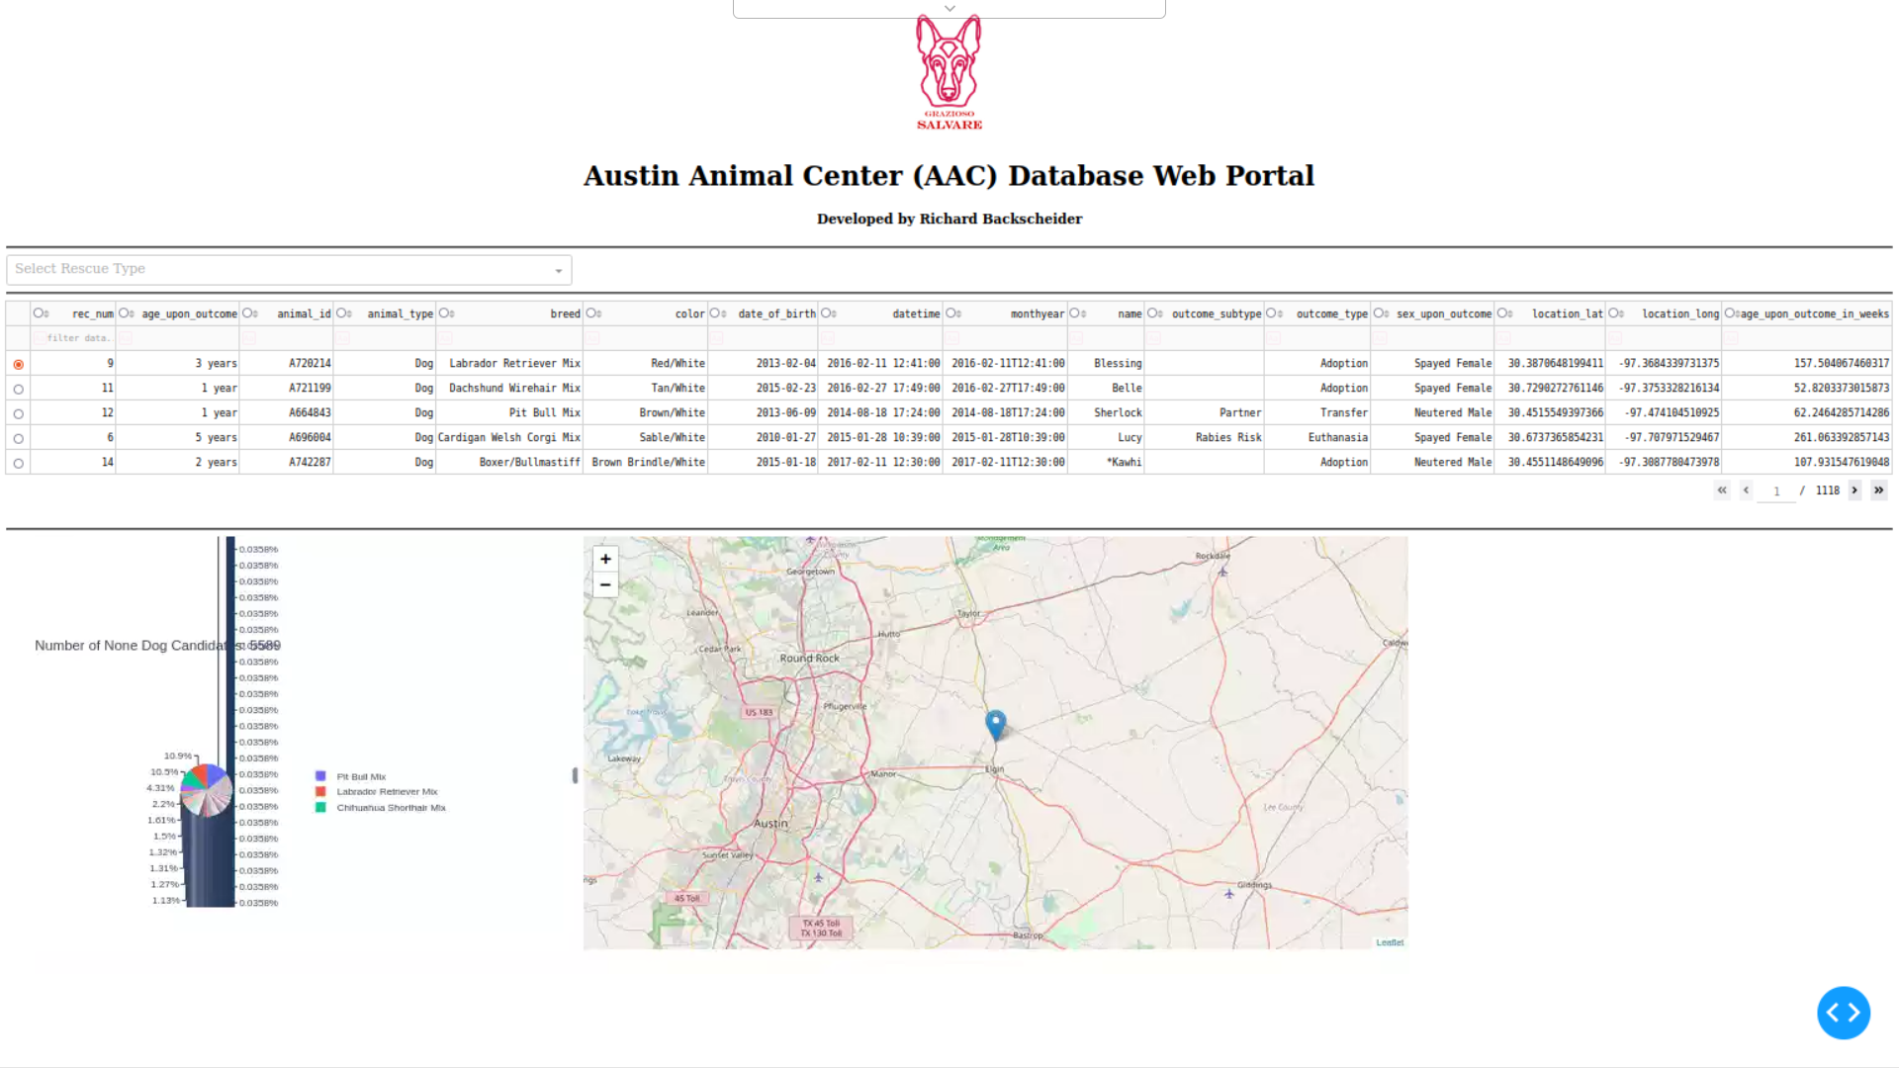

The above landing page is the result of the default query depicted in the code below, which returns all dogs listed in the animal’s collection.

Using Jupyter Dash, the data returned from the below query is processed and formatted into a clean and easy to read data table for presentation on a webpage.

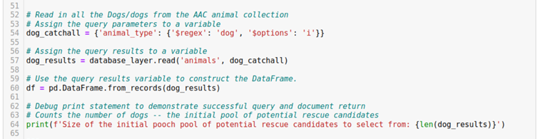

The above code is used to build the default landing page data table. The code below formats the data into a clean easy to read table with the Grazioso Salvare Logo and the title page centered at the top of the page. When the Grazioso Salvare Logo is clicked on, it presents the SNHU homepage.

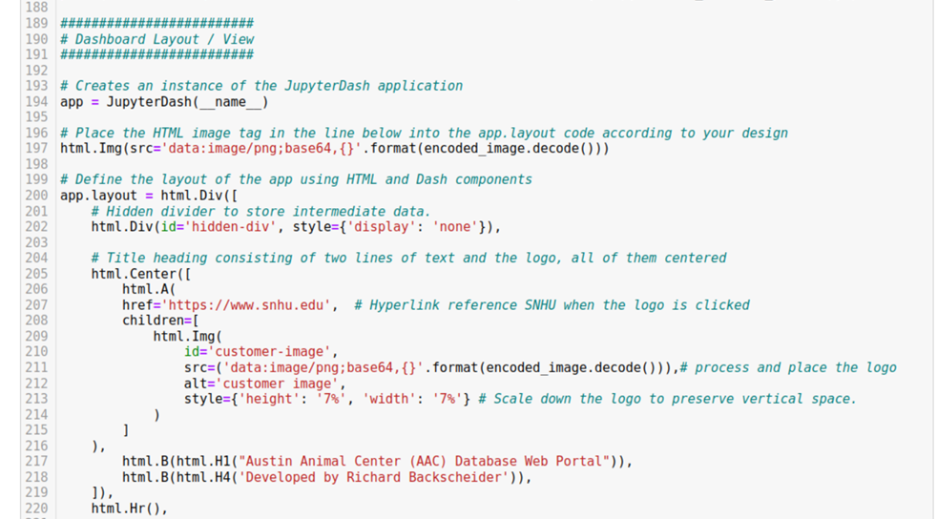

When a dropdown menu selection is made by the user, it activates a corresponding query that returns the desired set of dogs. The following code presents the data selected via the dashboard’s pulldown menu.

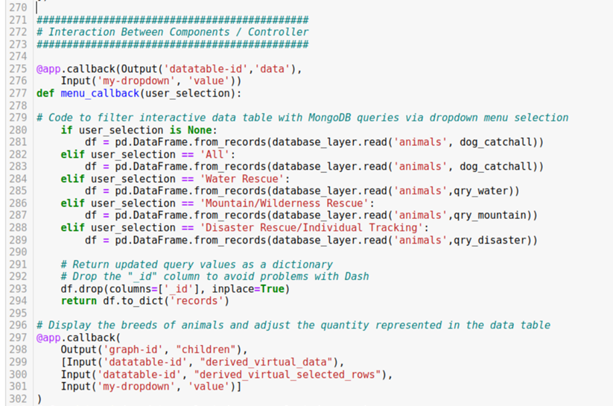

Located below the data table, are the pie chart and the geolocation map. Both of these are rendered using the same query data through the use of Dash Core Components. The Dash Core Component uses a query that corresponds to the dropdown menu selection to display a representative pie chart. The code responsible for that is in the below illustration.

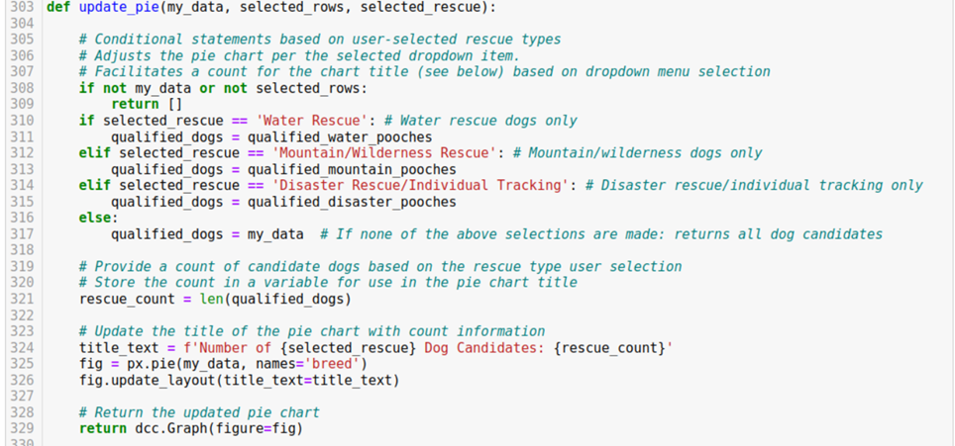

There is also a radio button on the left-side of each data table row which, when clicked, adjusts the geolocation map to the specific location of the selected dog. The code supporting this function can be seen below.

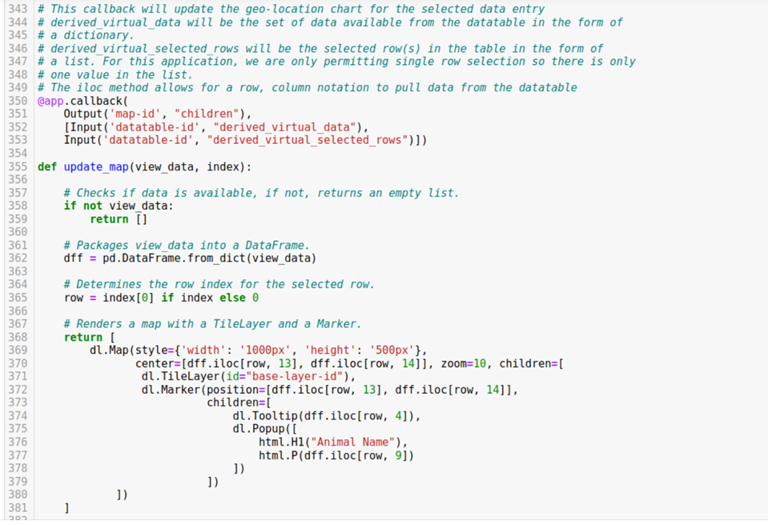

The following pages demonstrate the functionality of the datatable, pull-down menu, pie chart, and geolocation map.

## Usage

When the landing page is launched, table rows for all dogs in the database will be displayed. The pie chart will represent all dogs in the database, and the geolocation map will display the location of the dog listed in the first row using the latitude and longitude information provided in the database.

**Functionality**

**Dashboard Landing Page (All Dogs/Reset)**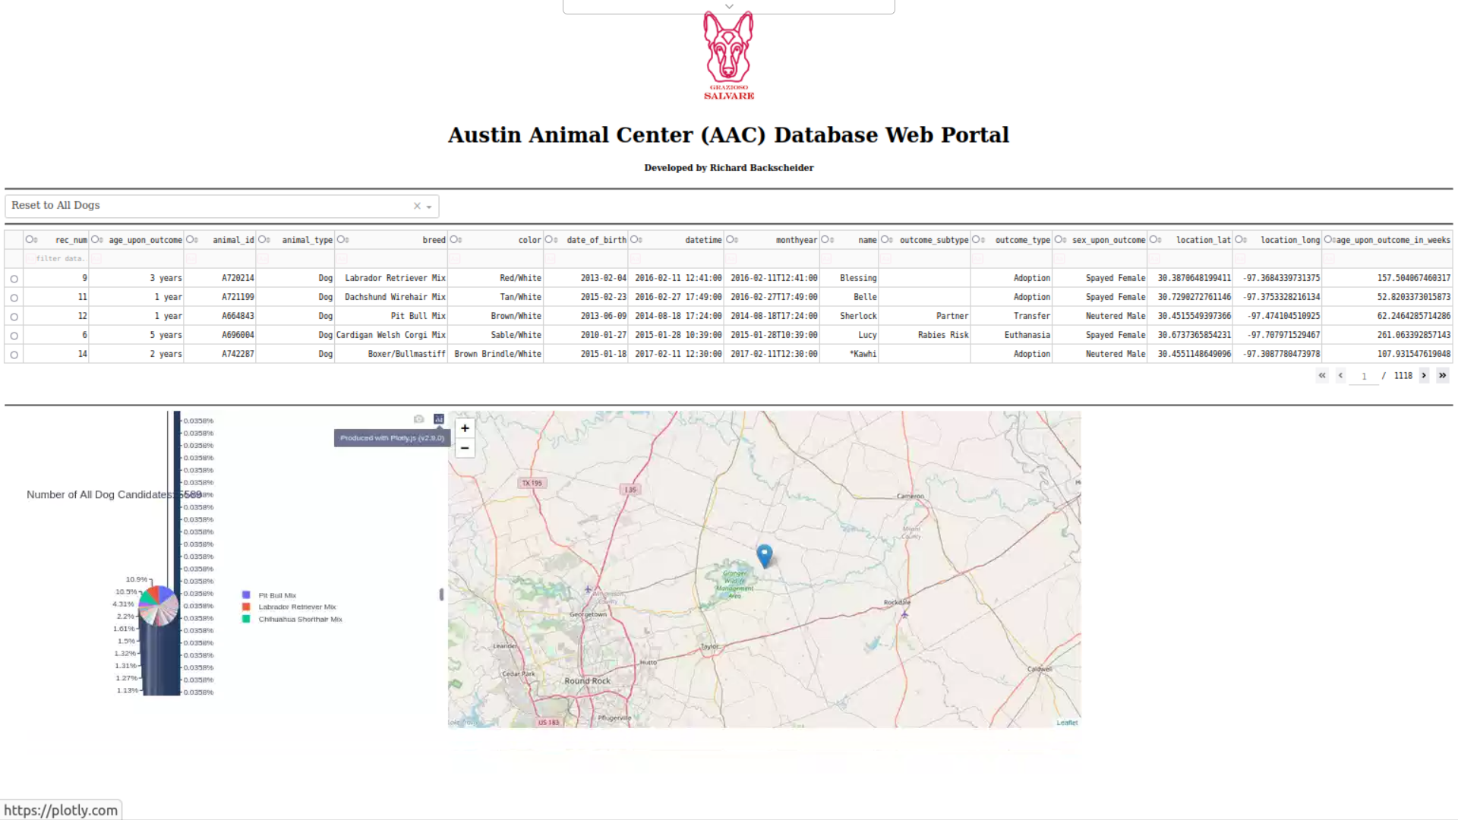

**Water Rescue Dog Candidates**

When “Water Rescue Dog Candidates” is selected from the dropdown menu, table rows for all water rescue dog candidates in the database will be displayed. The pie chart will represent only water rescue dog candidates in the database, and the geolocation map will display the location of the dog listed in the first row using the latitude and longitude information provided in the database.

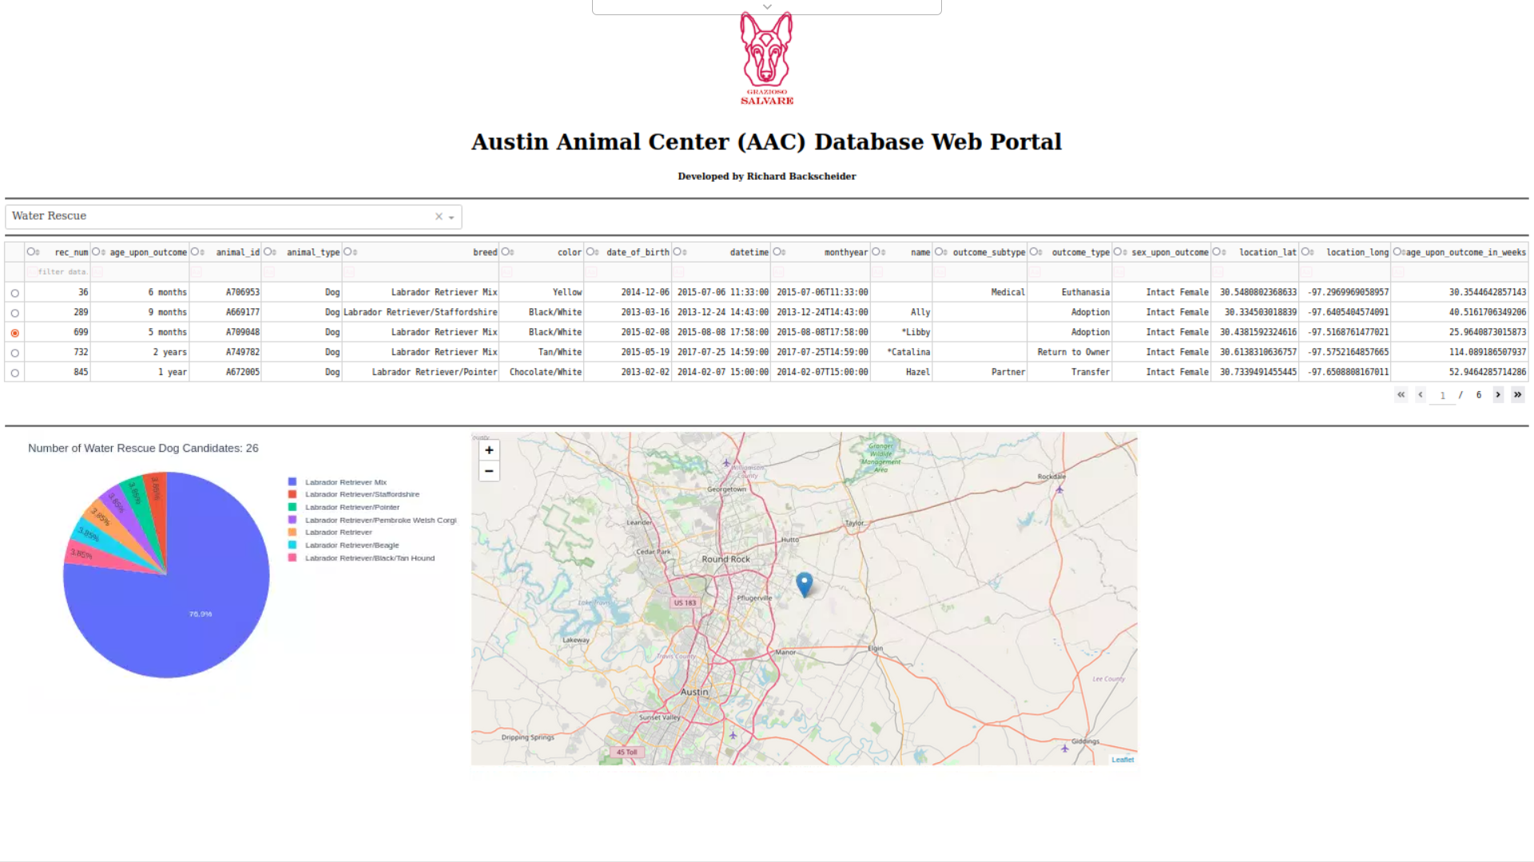

**Mountain or Wilderness Rescue Dog Candidates**

When “Mountain or Wilderness Rescue Dog Candidates” is selected from the dropdown menu, table rows for all mountain or wilderness rescue dog candidates in the database will be displayed. The pie chart will represent only mountain or wilderness rescue dog candidates in the database, and the geolocation map will display the location of the dog listed in the first row using the latitude and longitude information provided in the database.

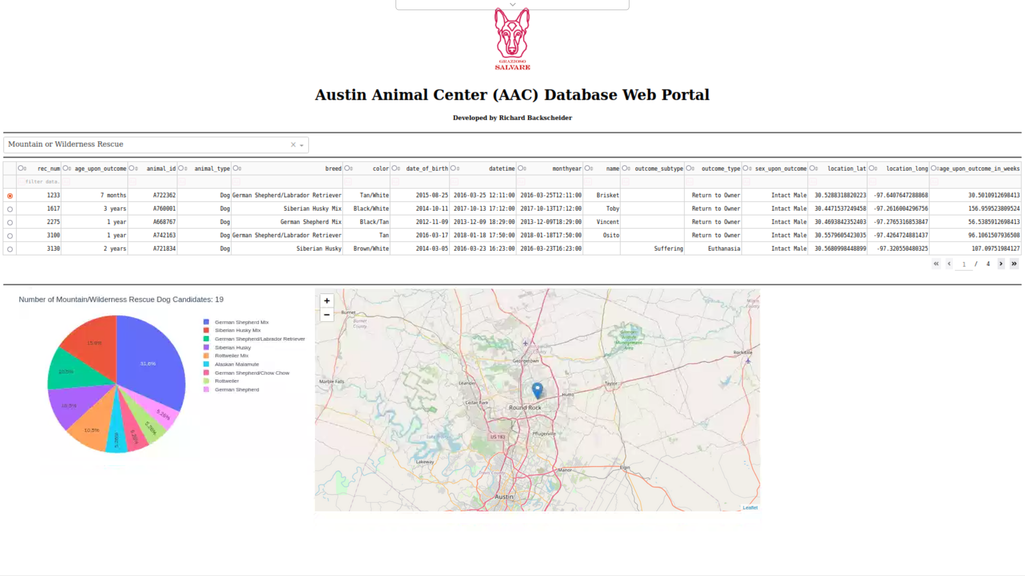

**Disaster Rescue or Individual Tracking Dog Candidates**

When “Disaster Rescue or Individual Tracking Dog Candidates” is selected from the dropdown menu, table rows for all disaster rescue or individual tracking dog candidates in the database will be displayed. The pie chart will represent only disaster rescue or individual tracking dog candidates in the database, and the geolocation map will display the location of the dog listed in the first row using the latitude and longitude information provided in the database.

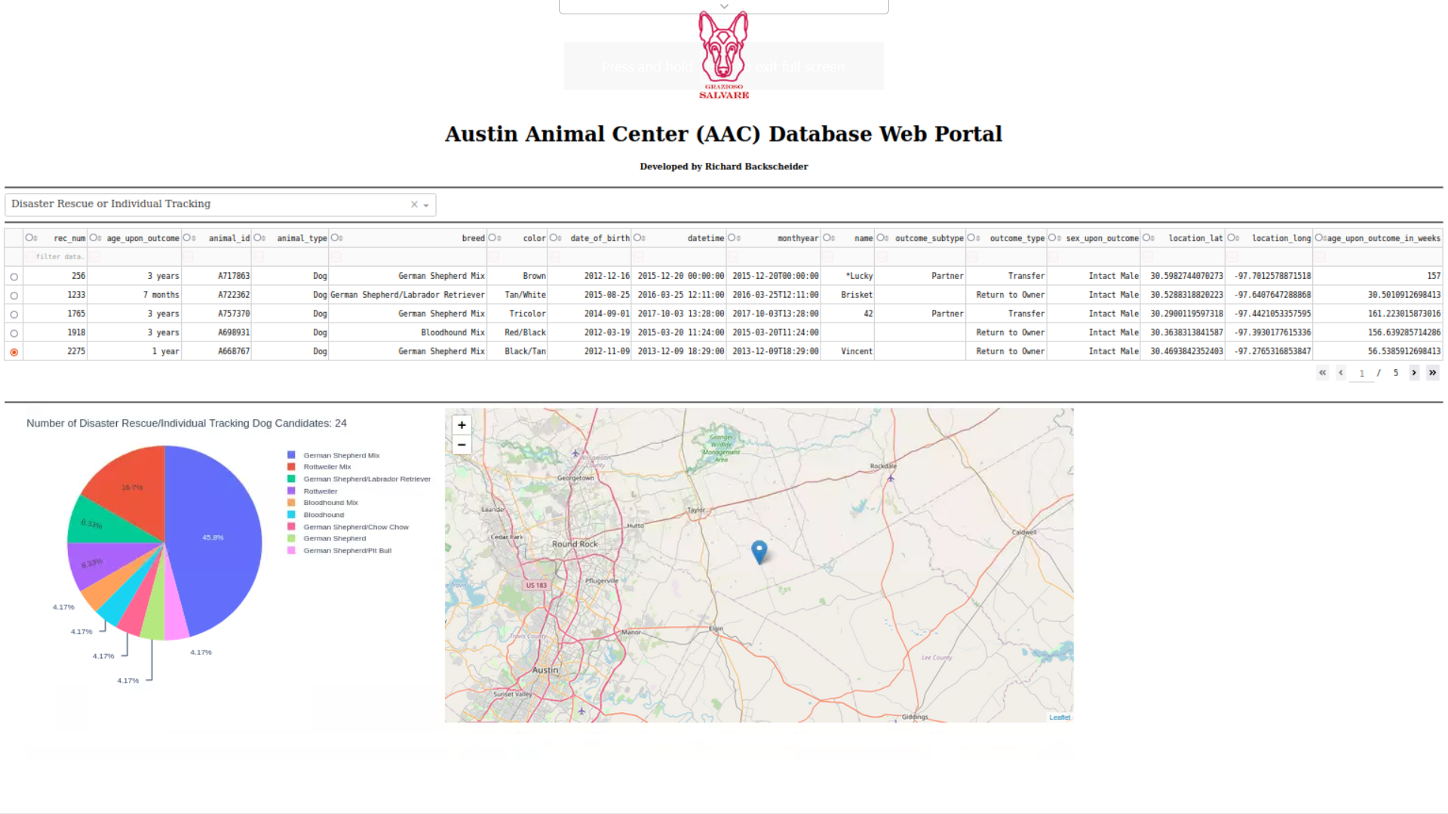

**Reset to all Dogs (Same as Landing Page)**

When the “reset to all dogs” is selected, all previous query filters are cleared and as a result all dogs are displayed. This menu item is the default for the program and therefore it serves as the condition for the landing page, when the program is launched.

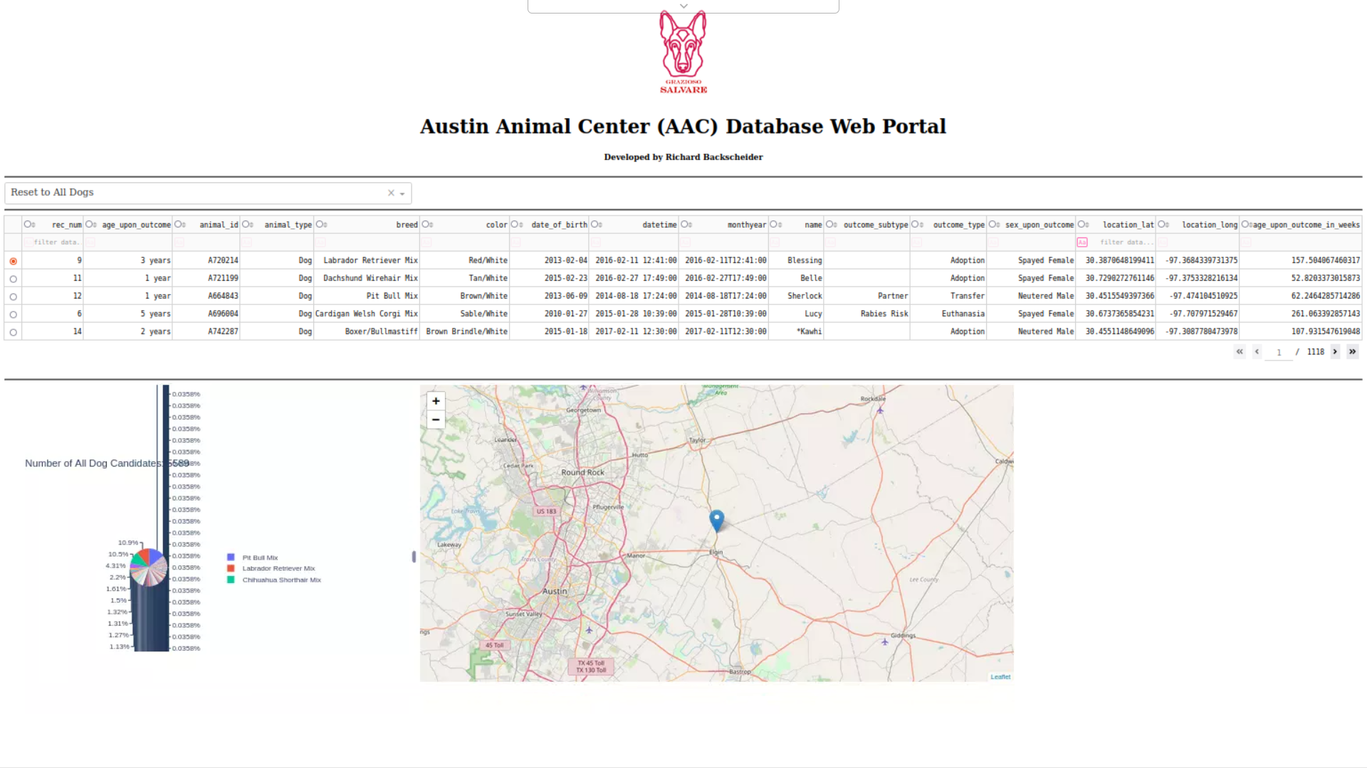

**Geolocation Map Interaction when Radio Button is Clicked (1 of 2)**

Each row of the datatable contains a “radio button” on the left most side of the table. When clicked, the geolocation map will display the latitude and longitude information contained within the row for that particular dog.

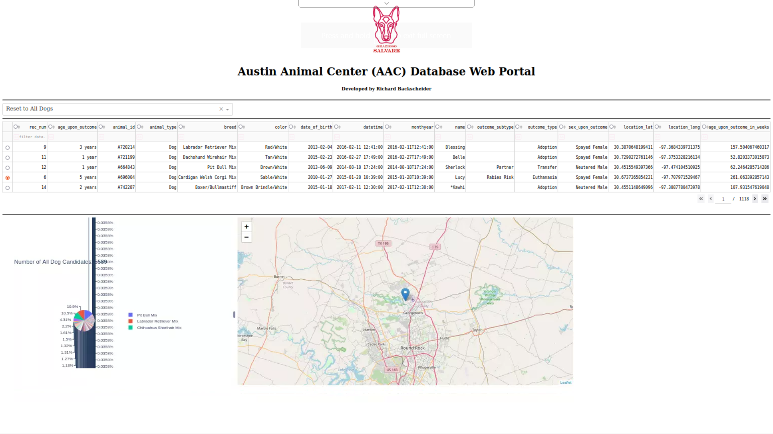

**Geolocation Map Interaction when another Radio Button is Clicked (2 of 2)**

The illustration below shows that the geolocation map changes when a different row is selected.

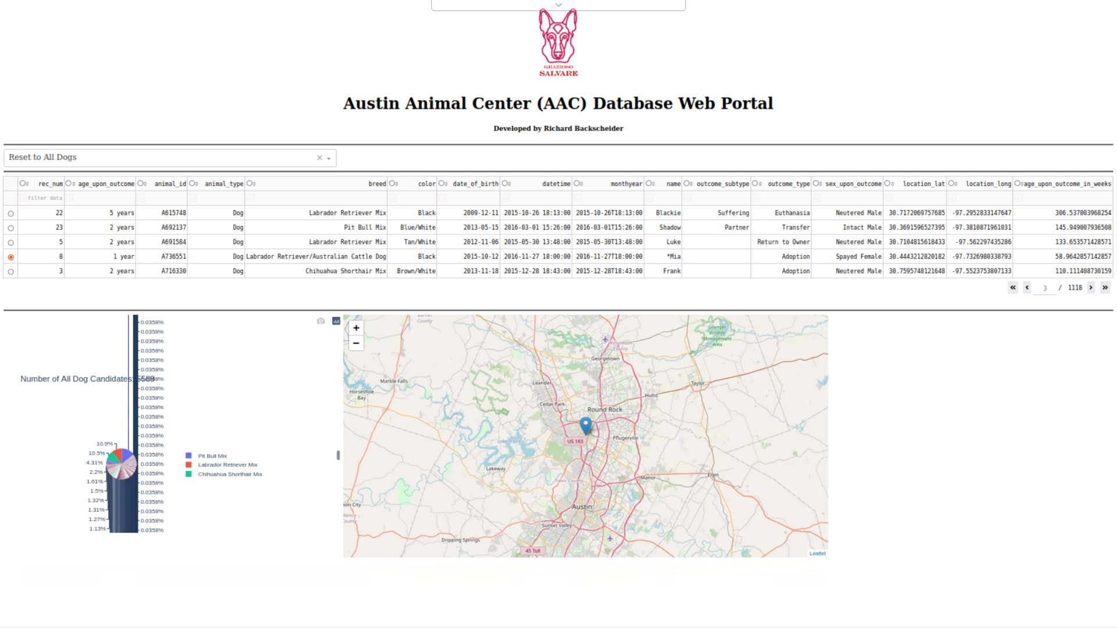

**Final Test that Logo Button Works**

Per the “Grazioso Salvare” specification sheet, the company logo should have www.SNHU.edu embedded within it. This facilitates the launch of the SNHU website, when the logo is clicked.

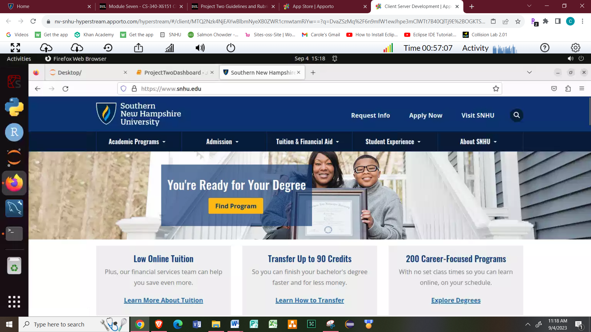

**Possible Challenges**

The biggest challenge I found with this project, was translating customer specifications for the various rescue type doge into actual queries in the code. I was able to overcome this challenge by reading the MongoDB and PyMongo resources provided within the learning modules.

**External links for helpful information**

MongoDB manual https://www.mongodb.com/docs/manual/

Mongo Shell Reference https://www.mongodb.com/docs/v2.4/reference/mongo-shell/

PyMongo – MongoDB Drivers https://www.mongodb.com/docs/drivers/pymongo/

## Dash Core Components https://dash.plotly.com/dash-core-components

## How to Use Jupyter Notebook: A Beginner’s Tutorial

## https://www.dataquest.io/blog/jupyter-notebook-tutorial/

## Make a README https://www.makeareadme.com/

## Contact

Richard Backscheider

CS-340 Client/Server Development